**LCD Interfacing with 8051 Microcontroller**

**Introduction**

The 8051 microcontroller is widely used in embedded systems due to its simplicity and powerful features.

To display output (like messages, sensor values, or user prompts), we often interface it with an **LCD (Liquid Crystal Display)**.

The most common LCD module used is the **16x2 alphanumeric display**, which can show:

* 16 characters per line
* 2 lines in total

**Basic Concept and Working Principle**

The 8051 microcontroller sends **ASCII data and commands** to the LCD using it’s **I/O ports**. The LCD processes these instructions and displays the corresponding characters.

The LCD has:

* **8 data lines (D0 to D7)** → For sending characters or commands.
* **3 control lines (RS, RW, EN)** → To control the operation of the LCD.

**Hardware Connections: LCD ↔ 8051**

**1. Data Lines (D0 to D7)**

* Connected to **Port 2 (P2.0 – P2.7)** of 8051.
* Used for transferring 8-bit data/command.
* ASCII values (e.g., 41H for ‘A’, 31H for ‘1’) are sent through these lines.

**2. Control Lines**

These are used to tell the LCD *what to do* with the data.

* **RS (Register Select)** – *Connected to P1.0*
  + RS = 0 → Instruction/command register
  + RS = 1 → Data register (display characters)
* **RW (Read/Write)** – *Connected to P1.1*
  + RW = 0 → Write operation
  + RW = 1 → Read (usually kept grounded to save time)
* **EN (Enable)** – *Connected to P1.2*
  + Acts as a latch
  + High-to-low pulse on EN → LCD latches the data

**3. Power and Contrast**

* **Vcc** → +5V power supply
* **Vss** → GND
* **Vee** → Contrast control pin
  + Connected to the middle pin of a 10k potentiometer
  + Adjusting the pot changes the screen contrast

**Step-by-Step Operation of LCD Interfacing**

**1. LCD Initialization**

Before use, the LCD must be initialized with a command sequence:

MOV A, #38H ; 2-line display, 5x8 dots

MOV A, #0CH ; Display ON, Cursor OFF

MOV A, #06H ; Entry mode set: Auto increment cursor

MOV A, #01H ; Clear display

These commands set the LCD in 8-bit mode, turn on the display, and clear it.

**2. Sending Commands**

* RS = 0 (command mode)
* RW = 0 (write)
* Place command (like 01H to clear screen) on P2
* Pulse EN (P1.2 high to low)

**3. Sending Data (Characters)**

* RS = 1 (data mode)
* RW = 0 (write)
* Send ASCII character to P2
* Pulse EN to latch

**4. Delay:** Give a small delay (using NOP or timer) to allow the LCD to process commands and show characters.

**LCD Interfacing Diagram (Draw this for your exam)**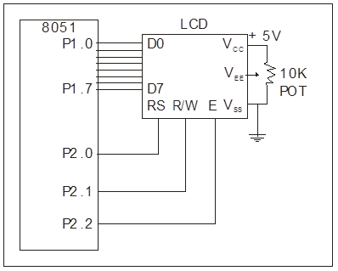

**Advantages of LCD with 8051**

|  |  |
| --- | --- |
| **Feature** | **Description** |
| **Readable Output** | Displays clear alphanumeric characters |
| **User-Friendly Interface** | Useful for menus, settings, and messages |
| **No External IC** | 8051 ports are directly usable (unlike 8085 needing 8255) |
| **Low Power** | Operates on 5V with minimal current |
| **Real-Time Data** | Ideal for debugging and live feedback |

**Applications**

|  |  |
| --- | --- |
| **Application** | **Purpose** |
| **Digital Clocks** | Shows time and date updates |
| **IoT Devices** | Display sensor readings or status |
| **Home Automation** | User interaction for settings and feedback |
| **Calculators** | Input and output characters/numbers |
| **ATMs & POS Systems** | Interface for entering PINs, amounts, etc. |
| **Consumer Electronics** | Microwaves, washing machines for displaying modes |